## FNO Production Checklist

### License Technology

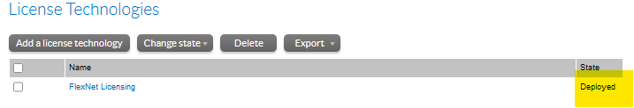

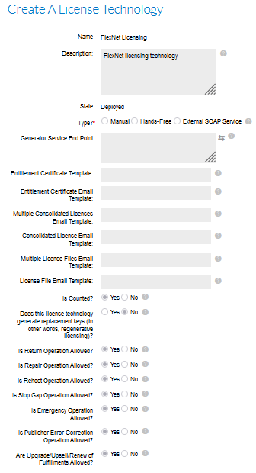

### License Generator

The demo license generator is used: this should be present by default.

### Custom Attributes

Ensure that DOWNLOAD_PACKAGE custom **product** attribute is defined as follows:

### License Model Attributes

Ensure that the following license model attributes are defined for FlexNet Licensing

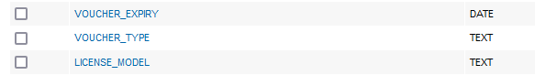

### Voucher Expiry

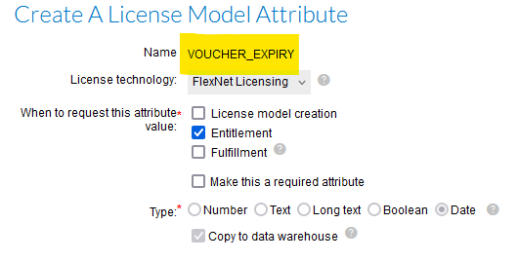

### Voucher Type

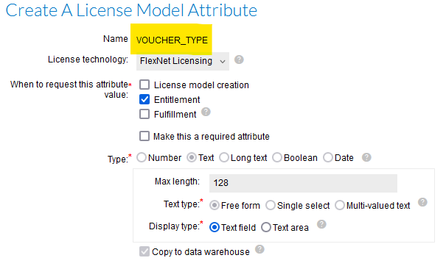

### License Model

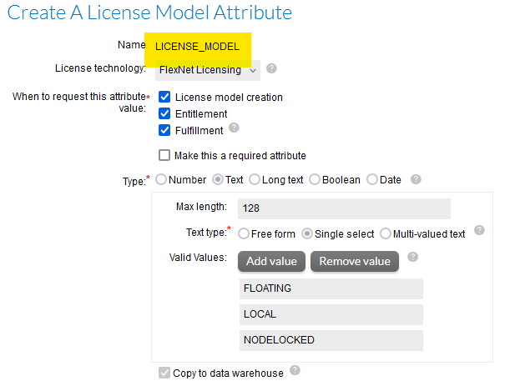

### Products, Features, and Part Numbers

Products, Features, and Part-numbers should be defined in accordance with the Software and Medical import templates in the following locations:

* [SOFTWARE](https://materialisenv.sharepoint.com/sites/extranet-Tiger_implementation/Tiger/Forms/Document%20Set/docsethomepage.aspx?ID=6139&FolderCTID=0x0120D52000883D6495DB4F994BA6AC0B21A523804E&List=5b8c9255-8909-4d54-92ab-c2dff5d04678&RootFolder=%2Fsites%2Fextranet%2DTiger%5Fimplementation%2FTiger%2FFlex%2DFlex%20Product%20Catalogue%20%2D%20Software&RecSrc=%2Fsites%2Fextranet%2DTiger%5Fimplementation%2FTiger%2FFlex%2DFlex%20Product%20Catalogue%20%2D%20Software&OR=Teams-HL&CT=1716450315710&clickparams=eyJBcHBOYW1lIjoiVGVhbXMtRGVza3RvcCIsIkFwcFZlcnNpb24iOiI0OS8yNDA1MDMwNzYxMSIsIkhhc0ZlZGVyYXRlZFVzZXIiOmZhbHNlfQ%3D%3D)
* [MEDICAL](https://materialisenv.sharepoint.com/sites/extranet-Tiger_implementation/Tiger/Forms/Document%20Set/docsethomepage.aspx?ID=6138&FolderCTID=0x0120D52000883D6495DB4F994BA6AC0B21A523804E&List=5b8c9255-8909-4d54-92ab-c2dff5d04678&RootFolder=%2Fsites%2Fextranet%2DTiger%5Fimplementation%2FTiger%2FFlex%2DFlex%20Product%20Catalogue%20%2D%20Medical&RecSrc=%2Fsites%2Fextranet%2DTiger%5Fimplementation%2FTiger%2FFlex%2DFlex%20Product%20Catalogue%20%2D%20Medical)

### Suites

Two DRAFT suites for Flex-Flex have been created in SIT and UAT to simplify the import process:

Each of the suites (above) includes ALL products that should be promoted to Production for each Product Line: note that all the products in a suite must share the same product Line which is why two suites have been defined; they are also configured with all three license models:

These suites do not need to be present in Production FNO.

## Portal Configuration

The login page should look like this:

### General Options

### Logon Page

### Portal Navigation

### End-User Portal Home Page

### Entitlements Page

### Bulk Entitlements Page

### License Support Page

### Devices Page

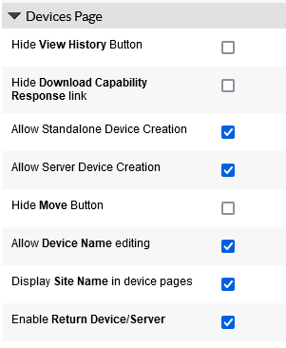

### Downloads Page

### Recent Releases and Others

### Manage Accounts and Users

### Custom Branding

Upload company logo and Upload header have been set

#### Colour Configurator

